

BANK

WORD

**Factors****Prime Number** **Composite Number**

**Two** **Prime Factorization** **Factor Tree** **Even**

**Area** **Evaluate** **Zero and one** **Odd**

|  |
| --- |
| **Fill in the Blank:** |

1. We use multiplication to find the _____________________________ of a shape.

2. A ___________________________ is a number that has ONLY two factors.

3. 4, 6, 8, 9 and 10 are the first five ______________________________________.

4. _______________________________________ are not prime and not composite.

5. ___________________________ means to solve or find the answer to a problem.

6. _______________________ is the only ______________________ prime number.



**Definitions:**

7. A prime number is _______________________________________________________

_________________________________________________________________________.

8. Factors are numbers that __________________________________________________

_________________________________________________________________________.

9. Composite numbers are __________________________________________________

_____________________________________________________________.

**Applications:**

10. Which number is composite?

A. 2 B. 3 C. 9 D. 11

**Bonus Question:**

Two factor trees have been complete below for the composite number 60. Create a third factor tree that leads you to the same **prime factorization** sentence of 2x2x3x5! Use **3x20** for the first two **factors**!

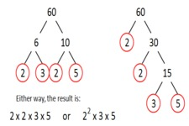

**SHOW YOUR WORK HERE!**

60