

BANK

WORD

**Sum** *Suma* **Difference** Differencia **Product** *Producto* **Quotient** *Cociente*

**Multiplication** *Multiplicación* **Dividend** *Dividendo* **Divisor** **Division**

**Addition** **Total** **Subtraction** **Table**

|  |
| --- |
| **Fill in the Blanks:** |

1. The _______________________________ is the answer to a division problem.



1. Find the difference means to use _______________________________.
2. ________________________ is another way of saying sum.

1. The bigger number in a long division problem is called the ______________________.
2. Find the product of two numbers means to use ______________________________.

**Definitions:**

6. Multiplication means ____________________________________________________.

7. The divisor is the number __________________________________________________

_________________________________________________________________________.

8. Division is ______________________________________________________________.

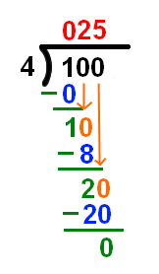**Applications:**

9. Circle the quotient of the problem below.

10. Underline the divisor of the problem.

