**Helping you achieve**

**your academic goals!**

**CLASS DOJO**

I will use the CLASS DOJO APP on my phone or tablet to track hallway and transition behavior. Students have learned the rules for walking in the hallway and transitioning between class and activities. Students who end up in the Red will receive a detention.

|  |
| --- |
| **230** |
| **225** |
| **220** |
| **215** |
| **210** |
| **205** |
| **200** |
| **195** |
| **190** |

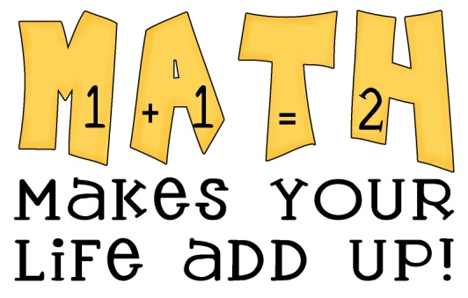C:\STOCKLAYOUTS\CURRENT PROJECTS\FN99803-PL\FN99803-IMG02.emf

**CLASS WEBSITE!**

[**http://mrcolemanmath.weebly.com/index.html**](http://mrcolemanmath.weebly.com/index.html)

**\*Visit everyday**

**Target MAP Score!**

**SEPT**

**IXL CHALLENGE: Students may use ixl for additional homework at any time!**

**class GOal: 12,000 problems by SEPT 30TH**

**HALLWAY**

**BEHAVIOR**

**MUST IMPROVE…**

**FUNDRAISING MONEY**

**DUE**

**MONDAY, SEPTEMBER 23RD**

STUDY YOUR FLASH

CARDS EVERY NIGHT!!!!

**2013**

**18**

*focus*

**FIND GRADES ON POWERSCHOOLS!**

STUDENT GRADES WILL BE UPLOADED TO POWER SCHOOLS AT THE END OF EACH WEEK.

IF YOU HAVE ANY QUESTIONS OR CONCERNS PLEASE EMAIL ME AT THE FOLLOWING ADDRESS BEFORE COMING TO THE SCHOOL.

**ron.coleman@new-haven.k12.ct.us**

**REFLEX MATH: STUDENT MAY PRACTICE REFLEX MATH FOR 10-15 MINUTES EACH NIGHT IN ADDITION TO WRITTEN HOMEWORK!**

Math